**Name: VISHNU SADASIVAN**

**Roll No: 52**

**Batch: B**

**Date: 21/04/2022**

**NETWORKING & SYSTEM ADMINISTRATION LAB**

**Experiment No.: 7**

**Aim**

Familiarization of Linux command.-part 5

**Procedure**

**1.read**

This command is in linux allows you to store a string in variable

**Syntax:** $ read variablename

**Output:**

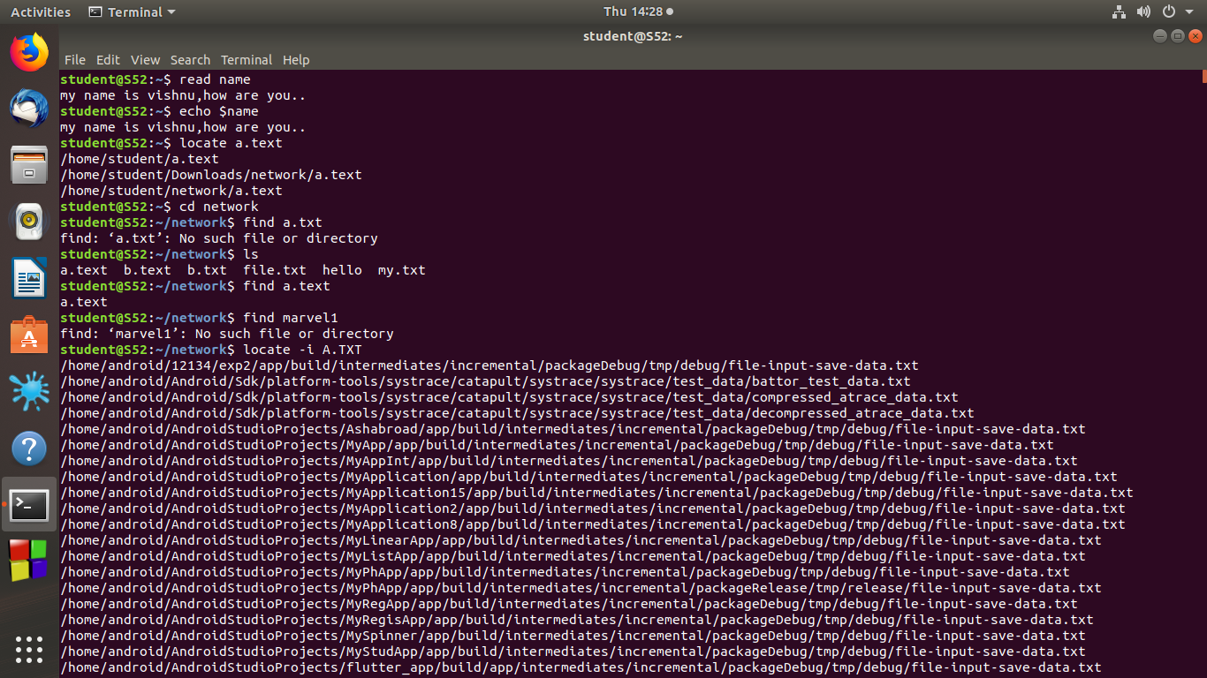

**2.find**

This command in linux allows you to locate a particular file which is in the same directory

**Syntax:**$network find filename

**Output:**

**3.locate**

This command in linux allows you to locate a particular file or directory from any location

**Syntax**: $locate filename

**Output**:



**4.locate -i :**

This command in linux allows you to locate a file without considering case.

**Syntax:**$ locate -i filename

**Output:**

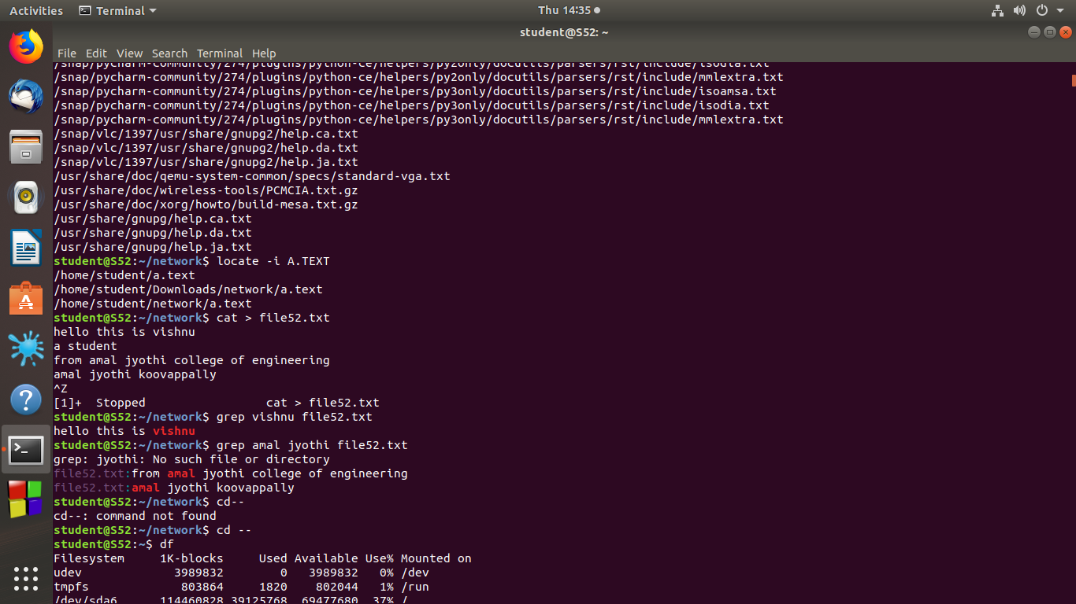

**5.grep**

This command in linux allows you to search all the text in a given file.

**Syntax**:$ grep word filename

**Output:**

**6.grep -i**

This command in linux allows you for case insensitive search

**Syntax**:$ grep -i word filename

**Output:**

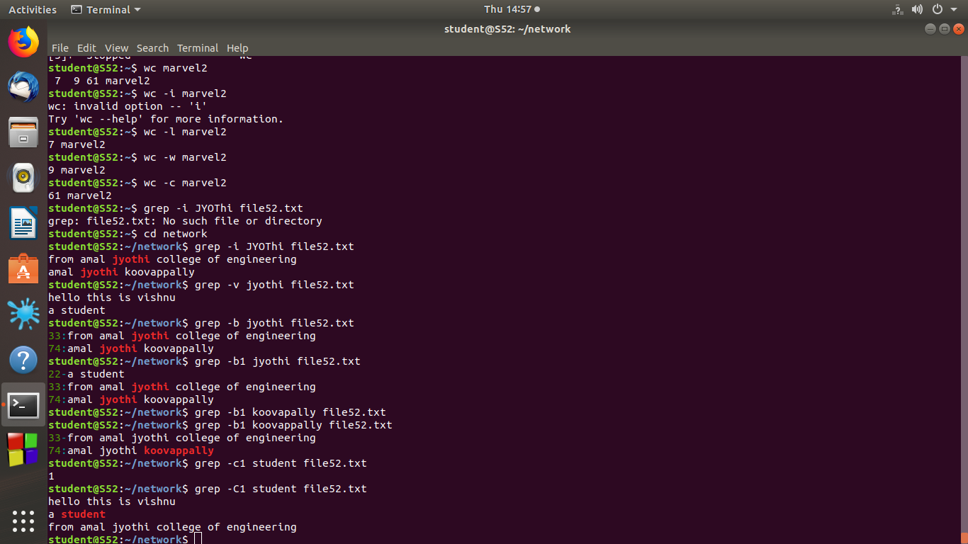

**7.grep -v**

This command in linux allows you to display all the lines that doesnot contain th e word we searched

**Syntax**: $ grep -v word filename

**Output**:



**8.grep -A:**

This command in linux allows you to print the word first and then print the lines in which it contain.

**Syntax:** $ grep -A <keyword><filename>

**Output:**

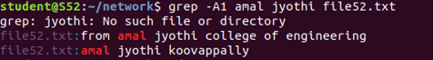

**9.grep -B1**

This command in linux allows you to print the content we searched and the line before the

content

**Syntax:** $ grep -B1 <keyword><filename>

**Output:**



**10.grep -C1:**

This command in linux allows you to print the content we searched and the line before the

Content and after the content

**Syntax:** $ grep -C <keyword><filename>

**Output:**



**11.wc -i:**

This command enable as to print the number of lines contains in a file.

**Syntax**: $ wc -i <filename>

**Output:**



**12.wc -w:**

This command enable as to print the number of words contains in a file.

**Syntax**: $ wc -w <filename>

**Output**:

**13.wc -C :**

This command enable as to print the number of words contains in a file.

**Syntax:** $ wc -C <filename>

**Output**:



**14.wc -m :**

This command enable as to print the number of bytes contains in a file.

**Syntax:** $ wc -m <filename>

**Output:**

